Name: M Shan Iftikhar

Roll No: BSAI-4A-017

Lab task 10

University admission chatbot

* Features of the Chatbot
* Natural Language Processing (NLP): Understands student queries
* Sentiment Analysis: Detects emotion in user messages
* Responsive Web Interface: User-friendly GUI built with Flask & HTML
* Predefined Q&A: Handles common admission-related questions
* Implementation
* Backend (Python Flask)

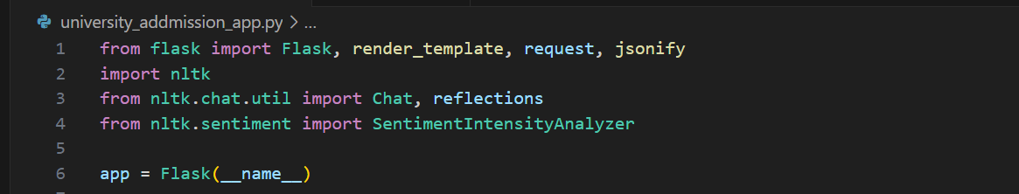

* Features
* Admission Queries Handling
* Programs, deadlines, requirements
* Sentiment Analysis Mode
* Detects emotion in user input
* User-Friendly Interface
* Clean web-based chat UI

1. Chatbot Responses

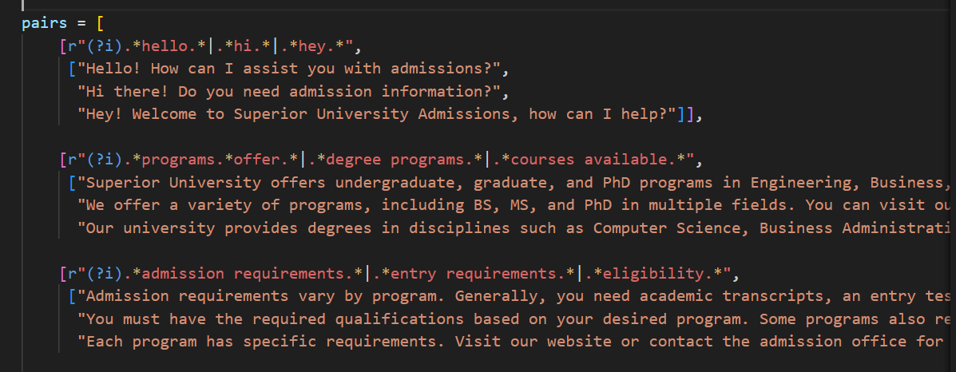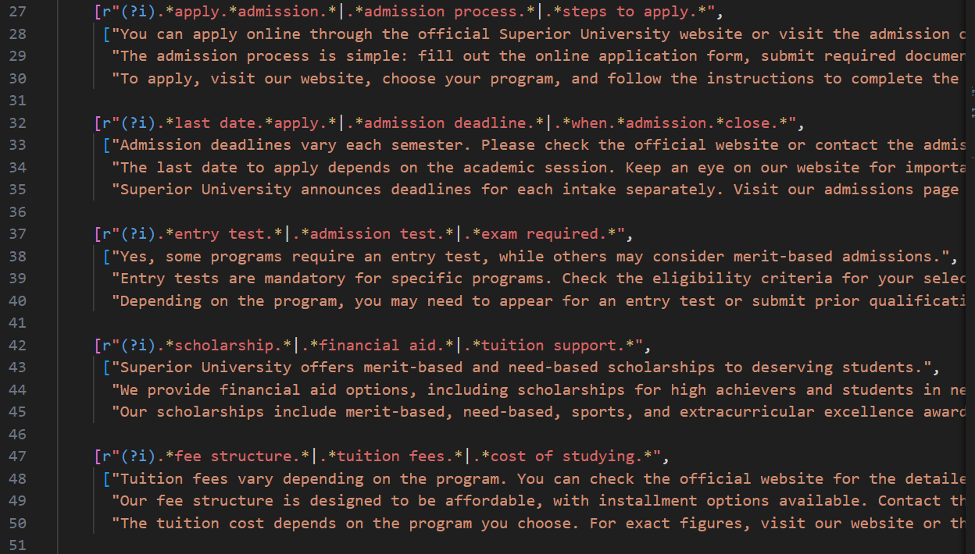

1. Sample Dialogues

User: What programs are offered?

Bot: We offer BS, MS, and PhD programs in Computer Science, Business, and Engineering.

* Function to get Response

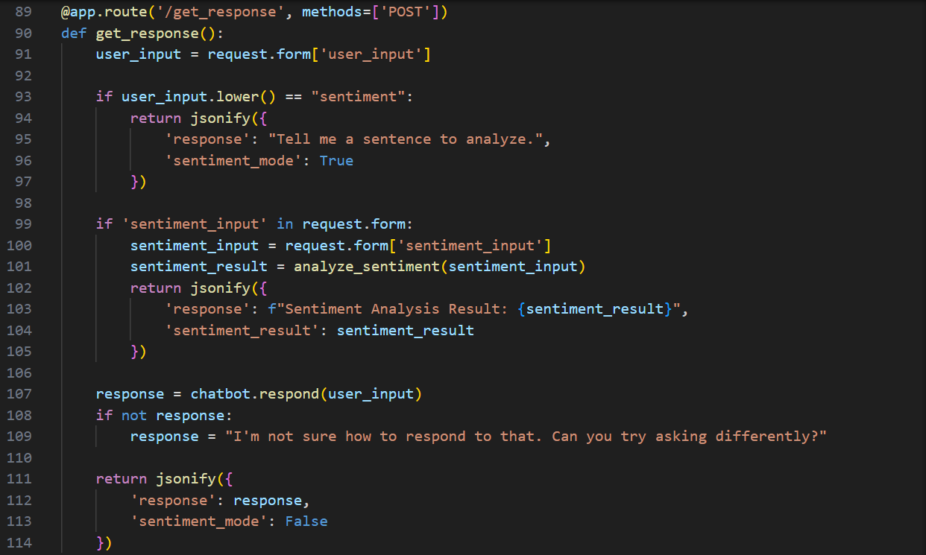

* Frontend (HTML)

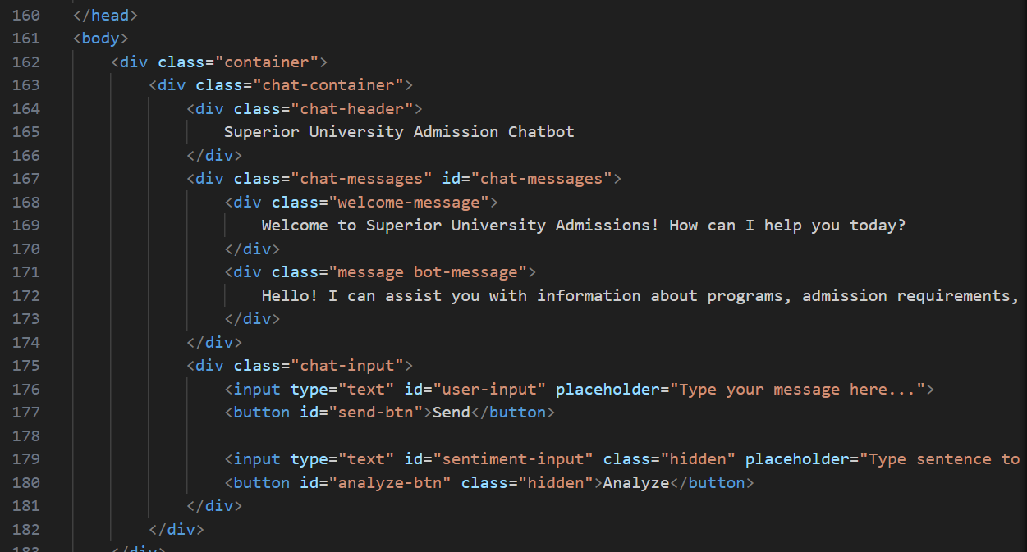

* Output

This University Admission Chatbot allows users to ask admission-related questions. It sends the user’s queries to a Flask-based chatbot server, receives AI-generated responses, and displays them in an interactive chat interface.

